Title: Football modelling project

<https://www.if.ufrj.br/~carlos/inic/gustavo/gustavo_jic.pdf>

<https://www.if.ufrj.br/~carlos/futebol/textoCatalogoExpo.pdf>

Which goal?

Variables to consider:

* The weight of the ball (internet)
* Air resitance (maybe?)
* Magmos force (formula in internet)

Strength, Direction, type of kick (effect?) which of the variables have to be different?

Using formulas such as f=ma

2nd differentiation w/ velocity/displacement

<https://www.youtube.com/watch?v=Xul9YKLLyT4>

### The FIFA World Cup is the international association football competition, widely regarded as one of the most competitive tournaments in the sport. Brazil holds the record of having won 5 times during the 21 tournaments (which happens continuously every 4 years). During the beginning of the COVID- 19 induced quarantine, due to the lack of live sporting events, I, as a football fan and amateur player, began watching iconic games. These included games from the 1970 FIFA world cup was where Brazil won its third title, its team is widely regarded as one of the best teams assembled, with several fantastic players including Pelé which is citied by some as being the best football player. During the group phase, more specifically Brazil match against Czechoslovakia (4x1), Pele saw the opportunity to kick the ball from before the half-way line in the goal’s direction, missing its destination by mere centimetres. Dubbed the goal Pele didn’t do, it has become famous for what would have been one of the greatest goals ever scored. This investigation has the objective to analyse the ball’s trajectory and see what factors should have different for Pele to have scored, taking into account several variables which may have had an effect.

### Aim and Rationale

### The aim of this investigation is to see which changes to certain factors would have increased the likelihood of the goal.

### Several physicists from the Federal University of Rio de Janeiro have used this kick as a case study to analyse different forces and how they affect the ball’s movement. They analysed pixel by pixel the footage from the game to try and gain accurate measurement. Thus, I will use the raw data they prepared for their own investigation. The link to their research will be in the references (however it is in Portuguese)

### I will be using Euler’s method which uses differentiation with a given initial value thus allowing me to form more accurate graphs.

### Graphs from a x and y perspective, from a y and z and from a x and z perspective

### Using calculus (second differentiation, for displacement and velocity)

### Modelling different variables together and apart

### Formulas such as the magnus force (picture below), force, air resistance, weight

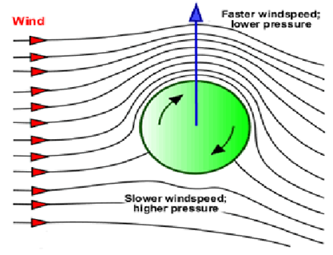 (<https://en.wikipedia.org/wiki/Magnus_effect>)

1 graph for considering the x axis and y so the distance and height travelled, with only his force

1 graph for considering the y and z axis meaning the direction of the ball

[https://calcworkshop.com/first-order-differential-equations/eulers-method-table/#:~:text=Euler's%20Method%2C%20is%20just%20another,to%20an%20initial%2Dvalue%20problem.](https://calcworkshop.com/first-order-differential-equations/eulers-method-table/#:~:text=Euler%27s%20Method%2C%20is%20just%20another,to%20an%20initial%2Dvalue%20problem.)